QUANTITATIVE ESTIMATION OF LAWSONE IN LAWSONIA INERMIS L. AND ITS MARKETED SAMPLES USING HPTLC
Snehal S. Phirke and Moitreyee Saha
Department of Botany, B. N. Bandodkar College of Science Chendani Bunder Road, Thane (W.) 400 601-India
sahamoitreyee@gmail.com
Abstract: Lawsonia inermis L. is commonly called henna. It is a medicinal and a popular dye plant. Since ancient time henna has been used as herbal dye to decorate hands, feet, beard, hair, etc. Local and commercial brands of henna powder are easily available in Indian market. Adulteration in market samples is nevertheless, one of the greatest drawbacks in promotion of herbal product. The adverse reports are due to presence of unintended herb or the use of chemicals in herbal products. The colouring property of henna is due to lawsone (2-hydroxy-1, 4- naphthoquinone). Synthetic hair dyes however, use chemicals to obtain a darker shade and to shorten the fixation time. These chemicals are sometimes found as an adulterant in henna preparations sold commercially as herbal dye by organized and unorganized sectors. Some herbal samples sold commercially are almost devoid of lawsone. Therefore in the present study, HPTLC technique was used for estimation of lawsone. The lawsone content found in leaf powders from field grown plants was 0.043 µg/mg [Kalyan, (M.S)] and 0.061 µg/mg [Jodhpur (Rajasthan)] of Lawsonia inermis L. In marketed samples (1, 2, 3, 4 and 5) of henna the lawsone content found was considerably lower i.e. 0.036 µg/mg, 0.0009 µg/mg, 0.0004 µg/mg, 0.001 µg/mg and 0.0006 µg/mg respectively.
Key words: Lawsonia inermis L., lawsone, marketed samples, HPTLC
Introduction
Lawsonia inermis L. (Lythraceae) is commonly called as Henna (Verghese et al., 2010). Leaves of henna contain the orange red dye, lawsone (2-hydroxy-1, 4-naphthaquinone). This molecule has an affinity for bonding protein and thus has been used to dye skin, hair, leather, silk and wool (Singh et al., 2008). Henna plant is widely cultivated as a dye plant in India (Phirke and Saha, 2013). Analysis of dried leaf powder showed orange colour in aqueous solution. Dried powdered leaves of henna contain about 0.5-1.5% lawsone (Muhammad and Muhammad, 2005), however, considerable variation in lawsone concentration has been observed ranging from 0.004 up to 0.608 % in Lawsonia inermis L. indicating that some samples were almost devoid of lawsone (Nagwa et al., 2007).
Now-a-days there is a renewed interest in drugs of natural origin. The advantage of natural drugs is that they are easily available, affordable and with less or no side effects but the disadvantage is that they are the victims of adulteration. The more effective the natural drug is, the more it is in demand. The chances of non-availability increases and to meet the growing demand, natural drugs are easily adulterated with low grade material. Adulteration or substitution is nothing but replacement of original plant with another plant material or intentionally adding any foreign substance to increase the weight or potency of the product or to decrease its cost (Chanda, 2014). Due to adulteration, faith in herbal drugs has declined. Adulteration in market samples is one of the greatest drawbacks in promotion of herbal products (Prakash et al., 2013).
In India suppliers add green coloured dye to henna powder in order to enhance its appearance. Major adulterant in henna leaves are stem, plant waste and other leaves. However in case of henna powder mixture of dyed sand is observed as an adultrant. The extent of adulteration is variable according to the price of the powder. Unlike Lawsone, the natural colour of henna, synthetic azo-dyes added may have an adverse effect on the skin. It is therefore, necessary to ensure that these artificial dyes are not present in the herbal products (Jones, 2002).
Identification and quality evaluation of crude herbal drug is a fundamental requirement. It is an accepted fact that the qualitative and quantitative analysis of bioactive or major chemical component of crude herbal drug constitutes an important and reliable part of quality control protocol (Gupta, 2003). The chromatographic fingerprints for herbal drugs has been used to highlight the impurity profile. It helps in identification and assessment of the stability profile of the chemical constituents (Wagner and Balt, 2003). The present research deals with the development of HPTC fingerprints of leaf powder of Lawsonia inermis L. and marketed samples which can be used for identification, authentication and quality assurance.
Materials and methods
In the present study field grown plants from Kalyan (M.S.) and Jodhpur (Rajasthan) were selected. Authentication of the plant was done (S.H.-1533) at Blatter Herberium, St. Xavier's College, Mumbai. The plant material was dried, powdered and stored in air-tight container.
Five marketed samples of henna powder from different manufactures (designated as Sample 1, Sample 2, Sample 3, Sample 4 and Sample 5) were procured from local market for the evaluation work.
Standard lawsone (97% purity) was procured from Sigma-Aldrich Cheime Gmbh (Aldrich Division, Steinheim, Federal Republic of Germany). The solvents methanol, toluene, ethyl acetate and acetic acid of analytical grade were purchased from Hi-media and used for analysis.
Preparation of Sample: 1 gm powder of Lawsonia inermis L. and marketed samples were weighed and placed in test tubes separately and 10 ml of 50% methanol was added. The sample was vortexed for 10 minutes and left to stand overnight at room temperature (28±2⁰C). The extracts were filtered through Whatmann No. 41 paper (E. Merck, Mumbai, India) and the filtrate was used for experimental work.
Preparation of Standard Stock Solutions: 10 mg of lawsone was dissolved in diluent (50% methanol) taken in 10 ml volumetric flask. Then the volume was made up to 10 ml with diluent to obtain a stock solution having 1 mg/ml concentration of lawsone.
Calibration curve of the standard: The working standard of suitable concentration (25-100 µg/ml) was applied in triplicate on HPTLC plate.
TLC Plates: Chromatography was performed on silica gel 60 F₂₅₄ HPTLC per-coated plate (15 cm X 10 cm) of 0.2 mm thickness.
Sample Application: Samples and standard lawsone (10µl) were applied on the plate as 8 mm wide bands with a constant application rate of 150 nL s⁻¹, with an automatic Camag Linomat V sample applicator under a flow of N₂ gas. The bands were positioned 5 mm from the bottom, 15 mm from the side and the space between two bands was 6 mm.
Development of Chromatogram: The linear ascending development was carried out in a Camag twin through chamber (20 cm × 10 cm), which was pre-saturated with 10 ml mobile phase i.e. toluene: ethyl acetate: acetic acid (5: 4: 1 v/v/v), for 30 minutes, at room temperature (25ºC ± 2ºC). The length of the chromatogram run was up to 80 mm.
Detection of lawsone: Quantitative evaluation of the plate was performed in the absorption-reflection mode at 278 nm, using a slit width 6 × 0.3 mm, with data resolution 100 mm step⁻¹ and scanning speed 20 mm s⁻¹ with baseline correction. The source of radiation utilized was a deuterium lamp.
Determination of lawsone: The amount of lawsone was determined from the Michaelis Menten Regression equation of calibration graph, plotted between area and concentration.
Statistical analysis: Determination of lawsone in field grown plant of Lawsonia inermis L. and its marketed samples were done in triplicate. Values reported are the mean of three measurements. The differences between experimental groups were compared by Kruskal – Wallis test followed by Chi Square Test. The results were considered statistically significant when P<0.05. (Table 1) (Zar, 2005).

Results and discussions
HPTLC analysis of field grown plants (Kalyan and Jodhpur) and various marketed samples of henna show the presence of lawsone in all samples with Rf value 0.70 (Plate 1).
Calibration curve of lawsone was obtained by plotting peak area verses concentration applied. It was found to be in linear range (25-100 µg/ml) per spot. The peak area and concentration was subjected to linear regression analysis to calculate the calibration equation Y=288.3X and regression coefficient (R²) was 0.648 (Figure 1).
The densitogram showed variation in lawsone content. The content of lawsone found in leaf powders from field grown plants was 0.043 µg/mg [Kalyan, (M.S)] (Plate 2) and 0.061 µg/mg [Jodhpur (Rajasthan)] (Plate 3) of Lawsonia inermis L., however, in marketed samples (1, 2, 3, 4 and 5) of henna the lawsone content found was considerably lower i.e. 0.036 µg/mg (Plate 4), 0.0009 µg/mg (Plate 5), 0.0004 µg/mg (Plate 6), 0.001 µg/mg (Plate 7) and 0.0006 µg/mg (Plate 8) respectively (Table 1). By statistical analysis it was observed that there is a significance difference between the lawsone content of field grown samples and marketed samples.
The presence of lawsone was confirmed in the leaf from field grown plants of Lawsonia inermis L. (Phirke et al., 2010). The content of lawsone was determined in dried and fresh leaves of Lawsonia inermis L. and it was found that dried leaves are better source of lawsone as compared to fresh leaves (Dhiman et al., 2012). Lawsone content was estimated in Lawsonia inermis L. plantlets regenerated in vitro and callus derived from leaf explants of in vitro seedlings (Phirke and Saha, 2014).
HPTLC fingerprinting showed variation in the concentration of lawsone and was found to be highest leaf procured from field grown plants as compared to marketed samples. Some samples were found to be almost devoid of lawsone. Therefore HPTLC fingerprint analysis can be used as a diagnostic tool for estimation of lawsone.
Conclusion
The present study was aimed to develop an analytical method for the estimation of lawsone, an active chemical constituent of Lawsonia inermis L. This chemical marker has a number of proven therapeutic properties. This study stresses the importance of scientific methods of proper identification and authentication of herbal products. These factors can certainly contribute significantly promoting ecofriendly herbal drugs for the health care of human society.
Acknowledgments
Authors are thankful to Botany Department, B. N. Bandodkar College of Science, Thane for providing the laboratory facilities and also Mrs. Milan Gholba madam for helping in statistical analysis.
References
- Chanda, S. (2014). Importance of pharmacognostic study of medicinal plants: An overview. Tistical Journal of Pharmacognosy and Phytochemistry, 2(5): 69-73.
- Dhiman, A., Sharma, K., Goyal, J., Garg, M. and Sharma, A. (2012). Determination of lawsone content in fresh and dried leaves of Lawsonia inermis Linn and its quantitative analysis by HPTLC. Journal of Pharmaceutical and Scientific Innovation, 1(2): 17-20.
- Jones, C. C. (2002). Henna under a microscope at 60X. Mehandi.com. Retrieved August 2014, from http://www.mehandi.com/closeup/powders1.html
- Nagwa S. E.; Badr J. M.; Maha A. A. and Gohar Y. M. (2007). Determination of lawsone in henna powders by high performance thin layer chromatography. Journal of Separation Science, 30(18): 3311 – 3315.
- Prakash, O., Jyoti, Kumar, A., Kumar, P. and Manna, N. K. (2013). Adulteration and Substitution in Indian Medicinal Plants: An Overview. Journal of medicinal plants studies, 1(4): 127-132.
- Phirke, S., Saha, M. and Naresh Chandra (2010). In vitro callus induction from leaf explants of Lawsonia inermis L. used as herbal dye, Asian J Exp Biol Sci, 26(3): 764-766.
- Phirke, Snehal S. and Saha, M. (2013). An overview of Lawsonia inermis L.: A Natural Dye Plant. Bionano frontiers, 6(2): 181-184.
- Phirke, S. and Saha, M. (2014). Determination of Lawsone by HPTLC in Lawsonia inermis L. Callus and Plantlets Regenerated in vitro. Asian Journal of Chemistry, Spl, 118-120.
- Wagner, H. and Bladt, S. (2003). Plant drug analysis. A Thin Layer Chromatographic Atlas. Published by Springer. Second edition, pp. 1-2.
- Varghese, J. K., Silvipriya, K. S., Resmi, S., Jolly, C. I. (2010). Lawsonia inermis (Henna): A natural dye of various therapeutic uses – A Review. Inventi Rapid Cosmeceuticals, 1(1):1-5.
- Zar, J. H. (2005). Biostatistical analysis. 4th edition published by Education Pte. Ltd., Delhi, India. pp 196-200.
Table 1: Amount of lawsone in plantlets regenerated leaf from field grown plant and marked samples of Lawsonia vinermis L.
Sample | Amount of lawsone present in sample (µg/mg) | R.S.D. (%) | S.E.
Leaf (Kalyan) | 0.043 | 2.91 | 0.55
Leaf (Jodhpur) | 0.061 | 5.4 | 0.31
Sample 1 | 0.036 | 5.7 | 0.69
Sample 2 | 0.0009 | 7.2 | 0.23
Sample 3 | 0.0004 | 5.1 | 0.07
Sample 4 | 0.001 | 8.62 | 0.18
Sample 5 | 0.0006 | 1.24 | 0.03
* Mean of three values
S.E – Standard error R.S.D – Relative standard deviation
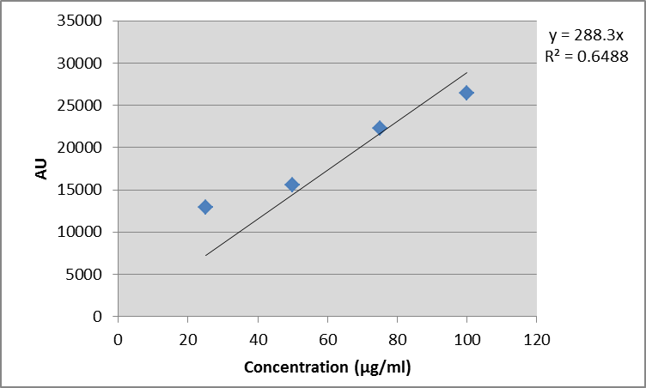

Figure 1: Calibration curve of lawsone by HPTLC
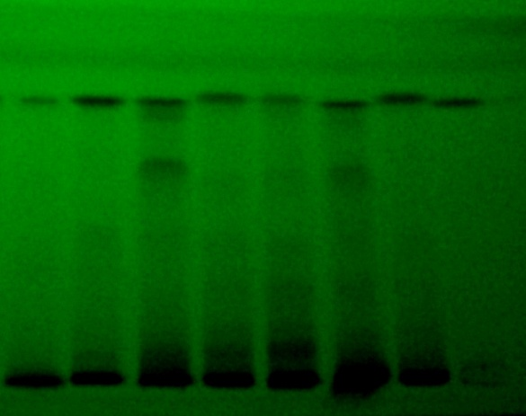
1 2 3 4 5 6 7 8
Plate 1: Chromatogram of leaf from field grown plant and marketed samples at 278 nm
1- Leaf (Kalyan); 2- Leaf (Jodhpur); 3- Sample 1; 4- Sample 2; 5- Sample 3; 6 - Sample 4; 7- Sample 5; 8 - Standard
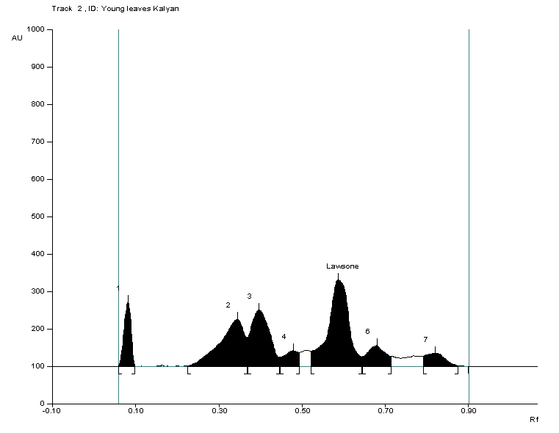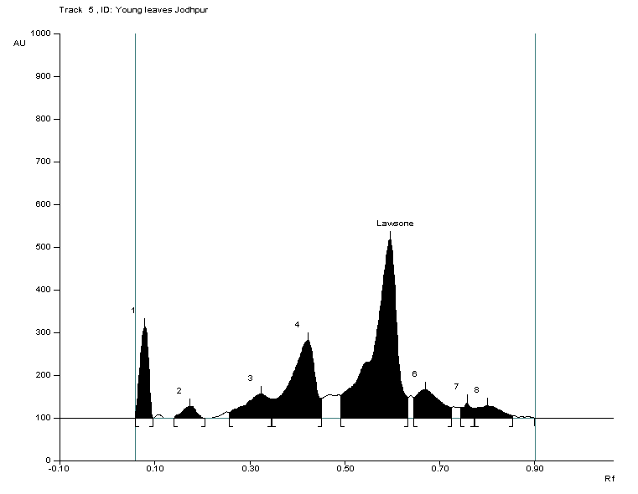

Plate 2: Densitogram of leaf from Lawsonia inermis L. (Kalyan) Plate 3: Densitogram of leaf from Lawsonia inermis L. (Jodhpur)

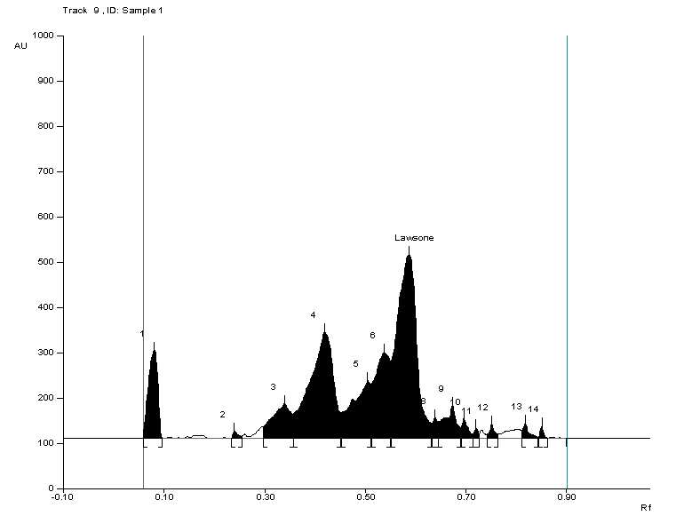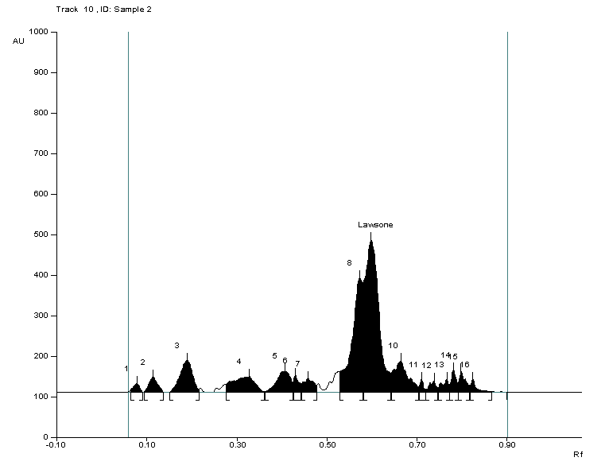

Plate 4: Densitogram of marketed sample 1 Plate 5: Densitogram of marketed sample 2

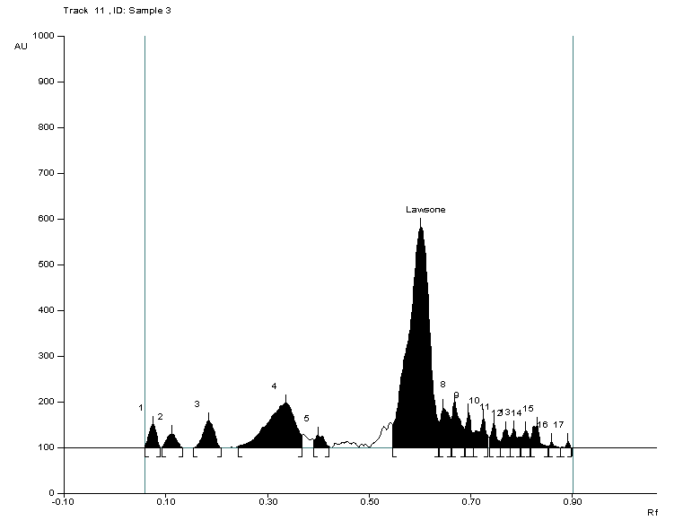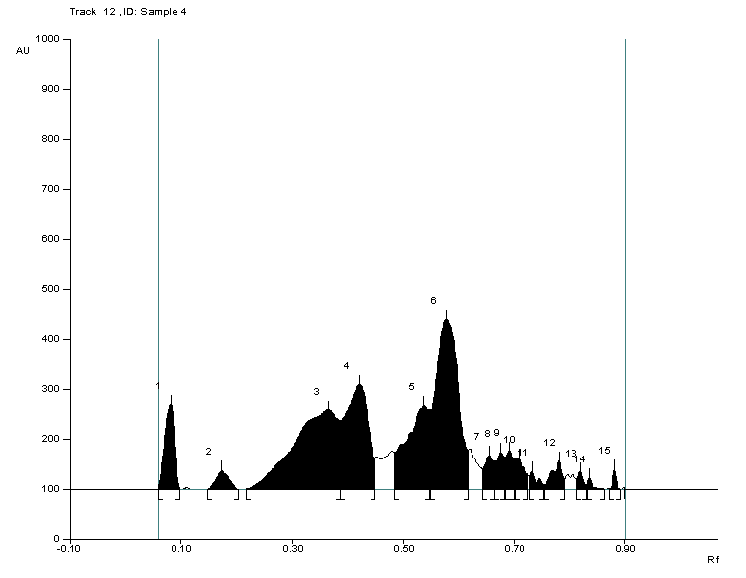

Plate 6: Densitogram of marketed sample 3 Plate 7: Densitogram of marketed sample 4

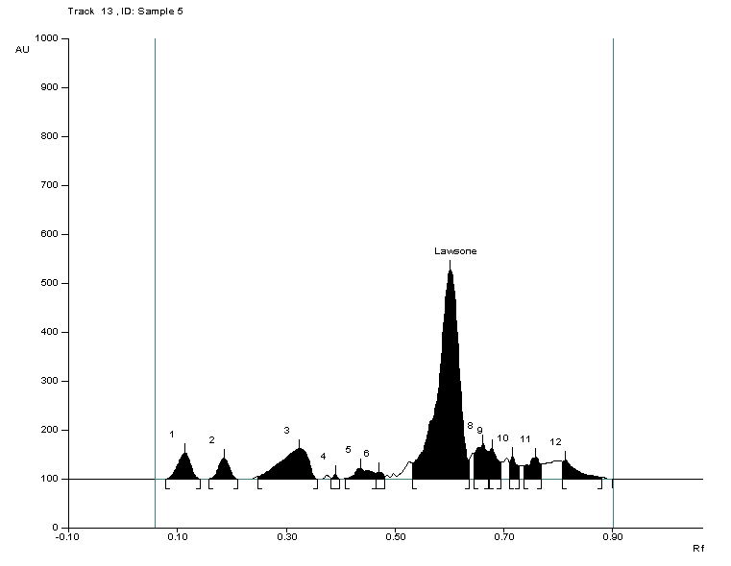

Plate 8: Densitogram of marketed sample 5

